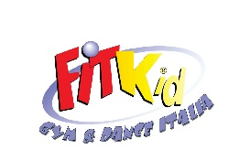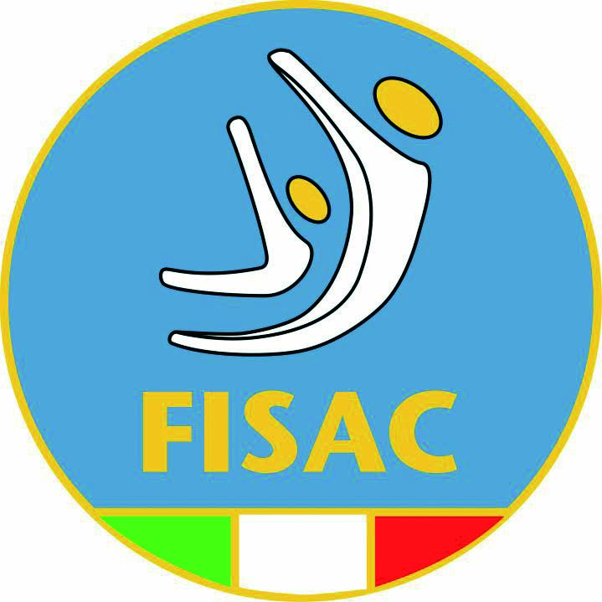
FITKID EUROPEAN CHAMPIONCHIP AND OPEN GRAND PRIX 2013
BEOGRAD ( SERBIJA 1/3 NOVEMBER 2013)
ADMISSION INDIVIDUAL COMPETITION
1° CATH.
LUCIA FIORINi
2° CATH.
SASSU MARIA ALESSANDRA
GIACOMINI NICOLE
3° CATH.
ANNA BERTOLINA
CAMILLA FIORINI
FICARRA ANNA
4° CATH.
MATILDE PRATO
MARIA PRATO
OUATTARA MARIAM (*)
ARIANNA RUPOLO(* if there is waivers)

5°CATH
KATIA BOEDDU
ARIANNA FALDANI
6° CATH
LAURA LA FACE
ZANNINI ALICE
ZAVA GIORGIA(*FREE pass)
7° CATH
SOFIA LORINI
SARA PELUSO

8°CATH
MONICA RASI CALDOGNO ( FREE PASS)
FOSCA SASSI
GIULIA DEFORTUNATO
ILARIA TURCHI
9° CATH
MARGHERITA TURCO (FREE PASS)
MELANIE BIRONDI
ALICE MIOTTO
JESSICA RUSSO
FW
GAIA BARLASSINA
GIULIA SERRA
CARMEN RUSSO

FBOY
ADRIANO SERNAGIOTTO
VALENTINO SERRA
PIETRO DEIANA

ADMISSION TEAM COMPETITION
DUO
1° CATH
BERTOLINA/ FIORINI
PIRRONE SASSU
2° CATH
PRATO PRATO
ZANNINI /POSEINATO
LA FACE/ PELUSO ( ***if there are waivers)
3° CATH
BIRONDI / RUSSO
SASSI/RASI
3 DUO ITALY(*** if there are waivers)
ADMISSION TEAM COMPETITION
LITTLE TEAM
1° CATH
BERTOLINA FIORINI FICARRA
2° CATH
PRATO/ PRATO /OUATT*
FALDANI/ MATTI/ BERTOLI (+1)
3° CATH
TURCO RUSSO BARLASSINA
SASSI PELUSO RASI
DE FORTUNATO TURCHI POTENZA ( LORINI**)
BIG TEAM
1° CAT.
team
2° CAT
FIORNI/ BERT/ PRATO/ PRATO/ PELUSO / LA FACE
MATTI/ BERTOLI/ GUATTERI/ ABDOUS/CIONI/ FRUSELLA*
3° CATH
ROSE
2 ITALY TEAM(*)

